RotaryMBS-Simple_RGB

**DISTRICT 6670**

**2020 GOLF OUTING**

**Friday, April 24**

[Snow Hill Country Club   
11093 State Route 73  
New Vienna, OH 45](https://plus.google.com/u/7/110632448539334932645)159

[(937)](tel:1-937-324-7725) 987-2922

[**www.snowhillcountryclub.com**](http://www.snowhillcountryclub.com)

**9:00 AM Start**

##### Breakfast, hole assignments, course and tourney instructions and begin at 8:30 AM.

##### ignments, course and tourney instructions and begin at 8:30 AM.

Men & Women Longest Drive

Putting Contest

50-50 Raffle

Mulligans

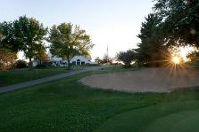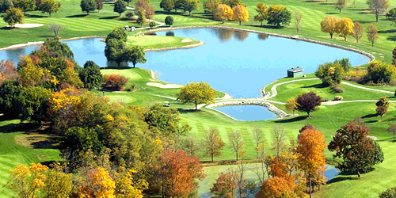

Entry fee is $85 per player, which includes continental breakfast, range balls, golf cart and lunch. Cash drinks are available. The format will be a four-person scramble. **Deadline for registration is April 20th.**

To compete for the coveted District 6670 Governor’s Cup, two members of the foursome must be from the same Rotary Club. Individual entries are welcome and we will assign you to a foursome. There will be prizes for both men and woman players. Please note: soft spikes only, collared shirts and no denim.

Contact Jim Perry (203-414-9400/513-836-3746) hole sponsorships of $100 are requested.

Contact Orville Bantz (937-545-9782) foursome of golf donations.

### **All proceeds from the Golf Outing will be contributed to The Rotary Foundation.**

----------------------------------------------------------------------------

District 6670 Sanctioned Entry Form:

|  |  |  |  |  |  |  |
| --- | --- | --- | --- | --- | --- | --- |
| Cost:  $85 per entry payable to:  **District 6670 Golf Outing**  ??? Mobile: 937-545-9782 | | **Mail Entry Form and Check To:**  **Orville Bantz**  **1788 s. Preble County Line Rd.**  **Farmersville, OH 45325** | | | | |
| **Golfer’s Name/Club** | | **(Golfer’s E-mail)** | | **$25 Donated to The Rotary Foundation** | **Mulligans**  **$10 ea. Max 2** | **Total**  **Each**  **Player** |
| 1. | |  | | $85 |  |  |
| 2. | |  | | $85 |  |  |
| 3. | |  | | $85 |  |  |
| 4. | |  | | $85 |  |  |
| Contact Ph. #: | |  | |  | **Tota**l |  |